Rates of Reaction Investigation

Task:

It has been said that “For every ten degree rise in temperature, reaction rate approximately doubles”.

Your task is to design, conduct and report on an experiment to investigate this statement with respect to the rate of the reaction between CaCO₃ and HCl.

Acids and carbonates react to produce carbon dioxide, a salt and water. For example, the reaction of calcium carbonate is shown below.

CaCO_{3(s)} + 2HCl_{(aq)} → CO_{2 (g)} + CaCl₂ _{(aq)}+ H₂O_{(l)}

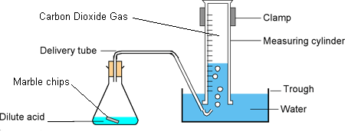
You will be provided with:
- the equipment shown in the diagram
- marble chips and powdered CaCO₃
- 0.1M and 1M HCl
- Ice and kettle
- Thermometers
- Beakers and common laboratory equipment

You will need to:
- Calculate the approximate quantities required given the equipment available. (Hint: The maximum volume of gas that can be collected is 100ml)
- Conduct preliminary trials to verify that your proposed method will work as planned

Assessment

You must submit a scientific report about your experiment. See Section 10.5 of Nelson for information about writing scientific reports. Your report marks will be allocated as shown below.

Section | Marks
Introduction | 4
Method | 3
Results (including table and graph) | 6
Discussion | 5
Conclusion | 1
References | 3
Language conventions | 4
TOTAL | 26

Your report will be worth 50% of the available marks for this task. The report is due Lesson 1, Week 2, Term 4.

You will also be required to complete a validation test about scientific inquiry and the experiment that you conducted. The validation test will be worth 50% of the available marks for this task. The validation test will be Tuesday Week 2, Term 4.

